Uptown Athletic Club Brochure
Welcome to the Uptown Athletic Club. We have locations all over the Tampa-St. Petersburg area to serve you. This brochure contains some of the reasons why you’ll find our athletic club to be the palace of all athletic clubs!

Why Start a Workout Routine?
Simply put, to get healthy! A workout routine gets you in prime shape through burning fat and building lean muscle. The human body is meant to be in motion and working out accomplishes that. Plus, studies have shown that people who work out regularly are not only stronger physically, but happier emotionally and mentally and make better life decisions overall as they tend to have strong critical thinking skills. All of that said, we want to make sure you get the most out of your workout routine, so the first step in starting a routine is to get a fitness assessment.

Why is a fitness assessment so important?
A fitness assessment is important because everyone is different. Some people need to start slowly while others can dive right in to our advanced workout programs. Some people will need to follow a doctor’s advice for any workout program. Others will need to tailor a workout program to avoid injury. Either way, it is important to get a fitness assessment. Our trained staff will start you with one and optimize your workout plan according to your assessment.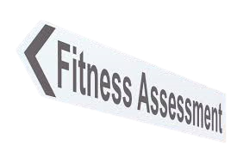
Some tips for a successful workout routine:
- Pick the best time of the day for you
- For some it will be mornings
- For others, evenings
- Get a consistent number of days a week going
- Make sure to stay hydrated while working out
- End each workout with a cooldown period
- Have a protein snack afterward
In short,

Here is what a sample weight training workout could look like:
- Warm-up
  - Stretch the upper body
  - Stretch the lower body
- Squats – 3 sets of 10 reps
- Rows – 3 sets of 10 reps
Note that our staff will help you with finding your ideal weights to use
Continue with:
- Deadlifts – 3 sets of 5 reps
- Overhead Shoulder Press – 3 sets of 10 reps
- Cooldown

Olympic Swimming Pool
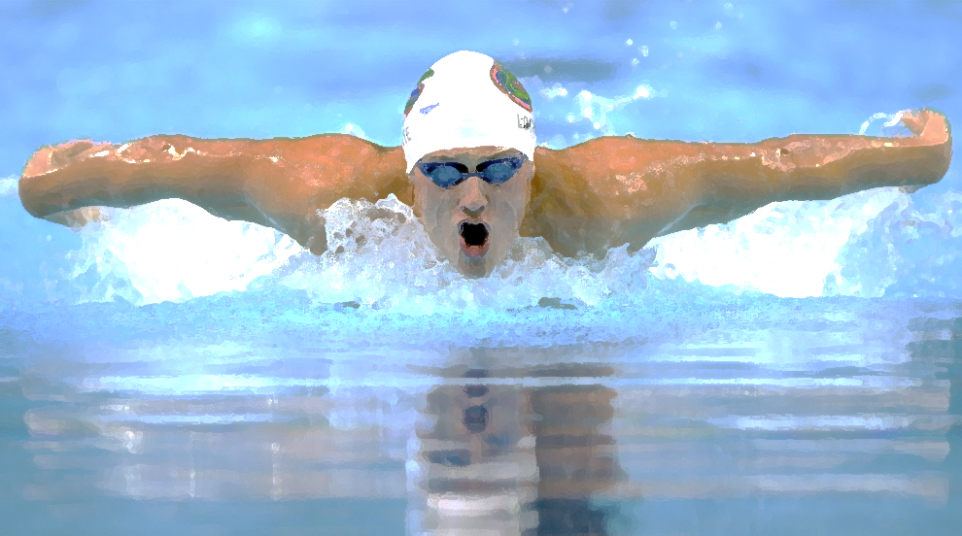We have an Olympic size swimming pool at every location. Our spacious pools allow for recreational swimming plus league swimmers can practice for competition. Plus, each location has a sauna and a hot tub to help you relax. Do note that you will need to pass a wellness check before you can use the sauna or hot tub.
This Photo by Unknown Author is licensed under CC BY-SA-NC

Benefits of Swimming
Swimming provides a healthy, low-impact type of exercise for people of all ages and all stages of physical fitness. When swimming, your only resistance is water. Swimming is therapeutic not only for the mind but also for the body.

Competitive Swimming
League swimmers will find that our pools resemble that of what they will find in competition. Swimmers can practice freestyle, the butterfly, the backstroke, and many other common swimming techniques. We also have trained swim coaches at many of our locations to help both experienced and beginner swimmers alike looking to get into competition. We have competitive swimming classes for people aged 5 to 95!

Feature piece of equipment: Kettlebell
One of our most popular weights for working out is that of the kettlebell. Why the kettlebell? Well, the kettlebell is a fun tool to work out with and it helps build muscle in many ways. First, because the hips are involved heavily in moving a kettlebell, this is a great way to build your posterior muscles. Secondly, with many upswings and downswings with a kettlebell, your last and abdominal muscles will get quite the exercise. Thirdly, kettlebell training increases your power and stamina. Lastly, because you must really hold on to a kettlebell while using it, kettlebells alone increase your ability to grip items, as kettlebells help strengthen your wrists, hands, and fingers.
So why not start using kettlebells as part of your workout routine, if, of course, you haven’t done so already!

Spotlight on: The National Council on Strength and Fitness
We at the Uptown Athletic Club have partnered with the National Council on Fitness and Strength for two reasons: first, they are a member-driven organization of exercise professionals. They have multiple accredited credential programs, including those for personal training, strength coaching, and sport nutrition. And, they are based right here in sunny Florida! Here is some more information on the organization, with further information available at ncsf.org:
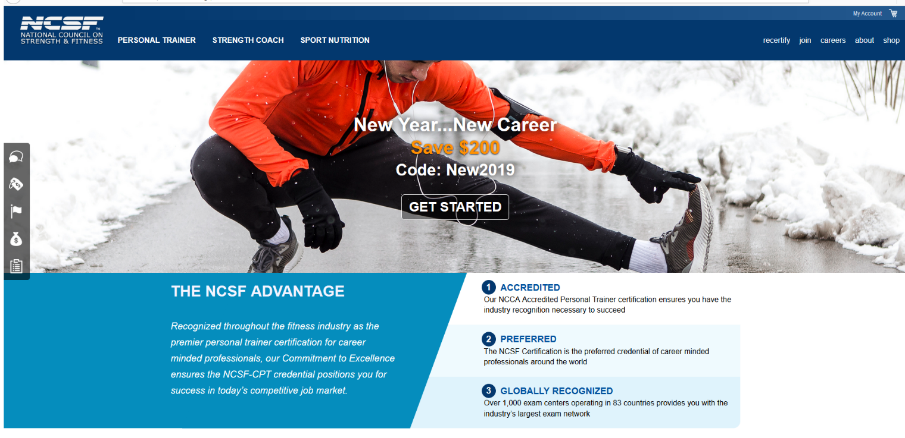
Remember:
For more information…
Ncsf.org
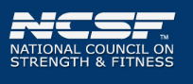

Love fitness?
Why not join our team?
Call 813-555-0029 for details.

Locations
Members enjoy a wealth of benefits and privileges for working out in our facilities. We have six locations to serve you, with athletic clubs in:
- Clearwater
- Dunedin
- Lutz
(Opening soon)
- Tampa
  - Dale Mabry
  - Downtown

Membership Pricing (per month)

Bronze - $9.99 and includes:
Weight machines
Cardio machines
Two classes a month

Silver - $19.99 and includes all the Bronze privileges plus:
The swimming pool and sauna
Three additional classes a month (for a total of five classes)

Gold - $29.99 and includes all the Silver privileges plus
Monthly one-on-one meetings with a nutrition specialist
Unlimited classes

